Detecting Manatee Calls Using NLMS and CUSUM

Zexi Liu

University of Florida

Gainesville, FL

zexiliu@ufl.edu

*Abstract*— In this project I design two machine learning detection approaches using Normalized Least Mean Squares (NLMS) algorithm and Sequential Probability Ratio Test (SPRT) and Cumulative Sum (CUSUM) algorithm to distinguish the manatee calls from the background noise. I select appropriate free parameters to train the models with ten manatee calls and background noise and test those models with test signal which includes unsegmented manatee calls mixed with background noise. I draw the ROC curve of both methods and compare the accuracy and running time of the two methods. The result shows that NLMS solution has higher accuracy and longer running time while CUSUM solution has lower accuracy and shorter running time.

Keywords— NLMS Algorithm, SPRT, CUSUM, Machine Learning, Call Detection

# Introduction

The manatee is a kind of marine and herbivorous mammal which is distributed in the Atlantic, Indian and Pacific Oceans. In recent centuries, the population of manatee has declined obviously, and the manatee has been extinct in many areas. The main factor of population reduction is due to the interference of human activities. Although it has been protected, it is still hunted from time to time in its habitat.

The purpose of this project is to design and evaluate a machine learning detection approach to distinguish the manatee calls from the background noise. In this project, I propose two manatee calls detection frameworks. The first framework uses NLMS algorithm. The second framework uses SPRT and CUSUM tests.

The rest of the paper is organized as follows: Section II presents the introduction of NLMS algorithm and the principle of detecting manatee calls by NLMS algorithm. Section III presents the introduction of SPRT and CUSUM tests and the principle of detecting manatee calls by SPRT and CUSUM tests. Section IV compares the accuracy and the running time of the two methods. Finally, Section V discusses results and makes a conclusion.

# Detecting Manatee Calls Using NLMS Algorithm

## Introduction of LMS and NLMS

The LMS adaptive algorithm is based on the steepest descent method. It is a very useful and simple method for estimating gradients. It was invented in 1960 by Stanford University professor Bernard Widrow and his first Ph.D. student, Ted Hoff. The biggest advantage of the traditional LMS algorithm is that the algorithm is simple, but its disadvantages are also obvious. For the traditional least mean square algorithm, the biggest defect is that it is too sensitive to the input amplitude. This makes it difficult for the designer to choose the suitable step size which can ensure the stability of the algorithm. In order to overcome these shortcomings, many methods have been proposed in recent years to improve the traditional LMS algorithm. NLMS algorithm is one of the most famous improved LMS algorithms.

Because the size of the input signal has an impact on the LMS algorithm, that is, under the same conditions, the signal with low energy will cause gradient amplification, and the algorithm with high energy will converge slowly. Normalize the input signal according to its average energy to obtain the normalized LMS algorithm. The principle of the NLMS algorithm is to minimize the mean square error of the predicted signal. The NLMS algorithm using an iterative algorithm is expressed as in:

$$\begin{aligned}\overline{w}\left(n+1\right)= \overline{w}\left(n\right)+\frac{η}{δ+{\left\|x\left(n\right)\right\|}^{2}}\overline{x}\left(n\right)e\left(n\right)\#\left(1\right)\end{aligned}$$

Note that w is the weight, $η$ is the step size, $δ$ is the compensation factor.

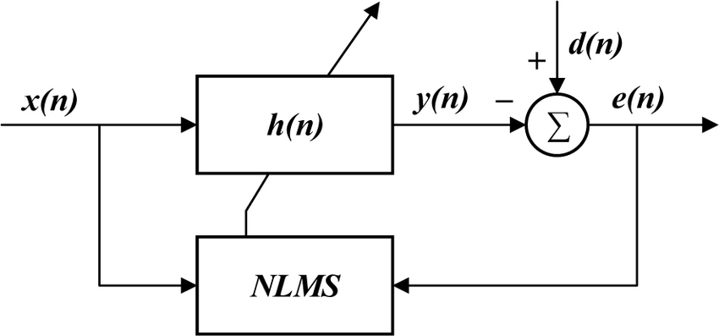

1. NLMS Algorithm Prediction Block Diagram

Fig. 1 shows the prediction block diagram of NLMS algorithm. The NLMS algorithm is the most important technology to improve the convergence speed. If we want to improve the convergence speed of the LMS algorithm, we can use a variable step size method to shorten its adaptive convergence process. Since the NLMS algorithm is relatively simple and easy to implement, it is widely used.

## Principle of Detecting Manatee Calls by NLMS Algorithm

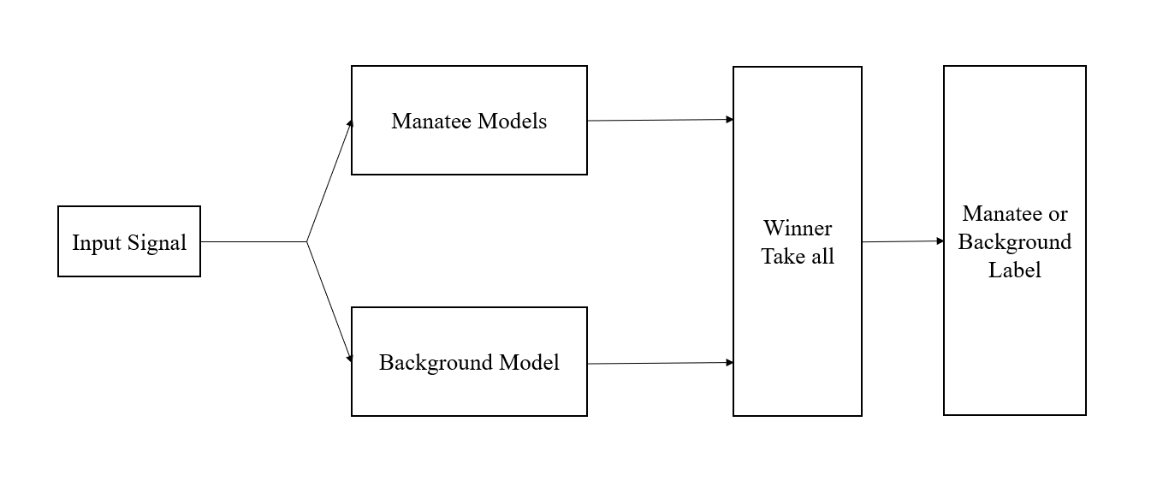

1. NLMS Solution Block Diagram

Fig. 2 shows the block diagram of NLMS Solution. There are two trained adaptive models, one to model the manatee calls and the other to model the noisy background. Each of these models will be trained as a predictor which predicts the manatee calls, and the noisy background respectively.

After the two models are developed, we can apply both of them in parallel to predict the test data set. Since they were trained for different time structures, the predictor that has the smallest error should represent the corresponding class (noise or manatee calls).

## Details of Training NLMS Models

Firstly, we have three data sets:

1. A file (train_signal.wav) with 10 different manatee calls segmented by the biologist that represent the signal class we would like to detect. The sampling rate is 48 KHz.
2. A 2 second noise background file (noise_signal.wav) that represents the acoustic noise picked up by the hydrophone. The sampling rate is 44.1 KHz.
3. A file (test_signal.wav) with unsegmented manatee calls mixed with background noise that lasts approximately 30 seconds. The sampling rate is 44.1 KHz.

In order to avoid the influence of sampling rate on the results, I resample these three files and set the sampling rate to 48 KHz.

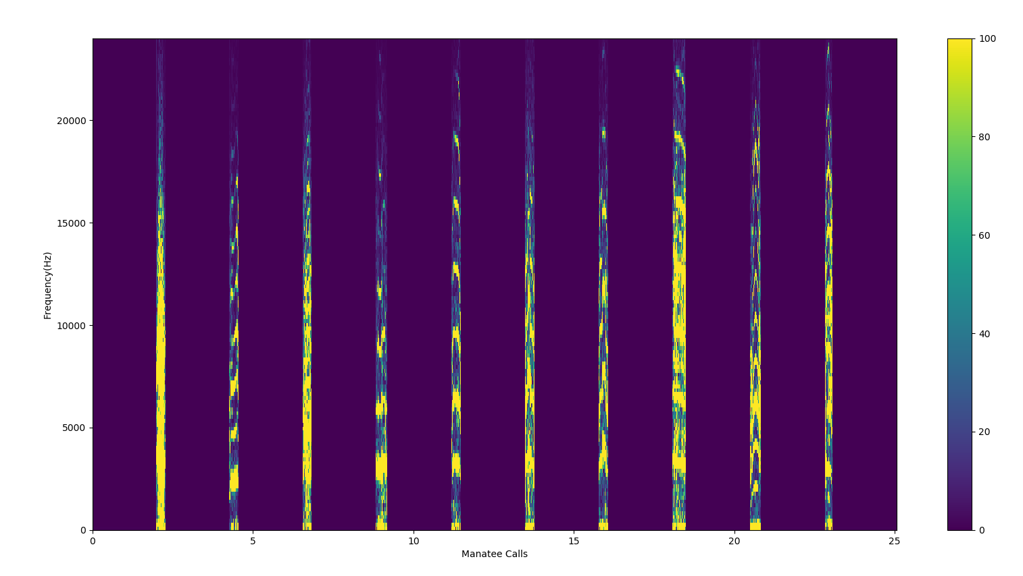

1. The Spectrogram of 10 different manatee calls

Fig. 3 shows the spectrogram of the ten different manatee calls. Form the spectrogram we can see that the frequency distribution of different manatee calls is different. So we need to train ten manatee call models for all ten different manatee calls to increase the accuracy instead of just training one model. So we need train ten manatee call models and one noise background model.

For each model, we need select the best step size and filter order. I use Mean Square Error (MSE) as the criterion to choose best step size and filter order. Firstly, I set filter order = 3 in all 11 models to select the best step size. TABLE I shows the step size which has the smallest MSE in each model.

1. Best Step Size For Each Model

|  |  |
| --- | --- |
| **Model Name** | **Step Size** |
| Manatee call model 1 | 0.012 |
| Manatee call model 2 | 0.027 |
| Manatee call model 3 | 0.011 |
| Manatee call model 4 | 0.035 |
| Manatee call model 5 | 0.012 |
| Manatee call model 6 | 0.010 |
| Manatee call model 7 | 0.006 |
| Manatee call model 8 | 0.008 |
| Manatee call model 9 | 0.048 |
| Manatee call model 10 | 0.014 |
| Noise Background model | 0.012 |

After selecting the best step size, we need select the best filter order for each model. I set step size = the best step size showed in TABLE I in each model to select the best filter order. TABLE II shows the filter order which has the smallest MSE in each model.

1. Best Filter Order For Each Model

|  |  |
| --- | --- |
| **Model Name** | **Filter Order** |
| Manatee call model 1 | 4 |
| Manatee call model 2 | 20 |
| Manatee call model 3 | 4 |
| Manatee call model 4 | 18 |
| Manatee call model 5 | 17 |
| Manatee call model 6 | 15 |
| Manatee call model 7 | 16 |
| Manatee call model 8 | 15 |
| Manatee call model 9 | 20 |
| Manatee call model 10 | 20 |
| Noise Background model | 7 |

## Test Result

After training the 11 models with the best step size and filter order, I apply all of them in parallel to predict the test data set. Since they were trained for different time structures, the predictor that has the smallest error should represent the corresponding class. In other words, if the smallest error in any of manatee call model 1 to manatee call model 10, the sample should represent the manatee call. If the smallest error in the noise background model, the sample should represent the noise background.

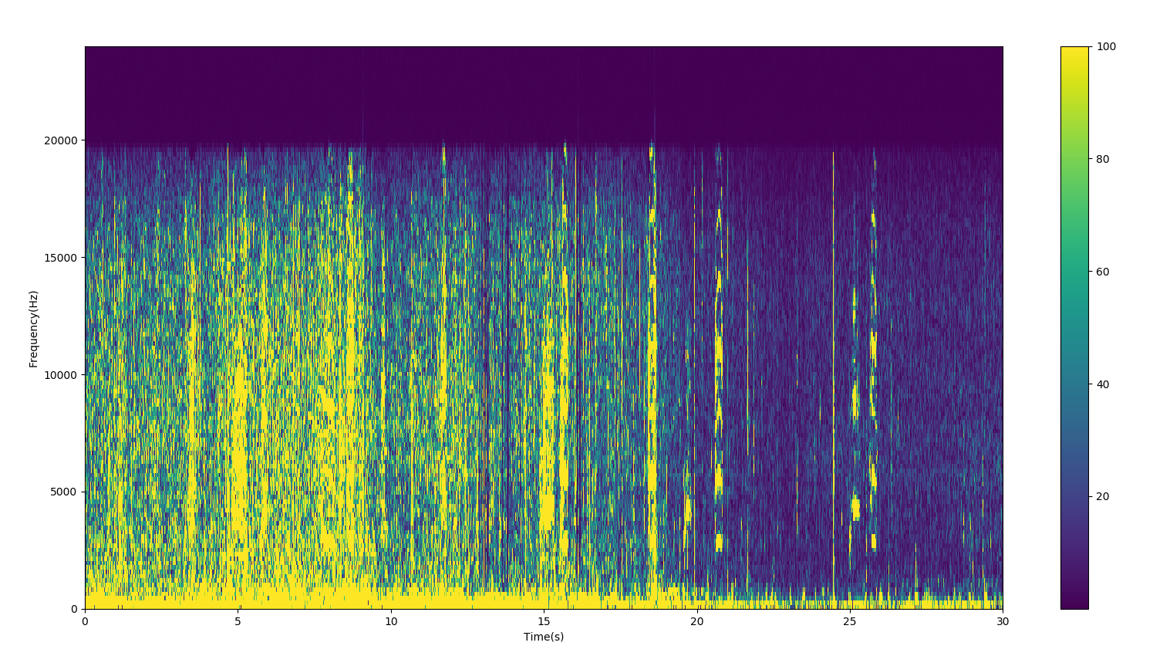

1. The Spectrogram of Test Signal

Fig.4 shows the spectrogram of the test signal. We can see that there are much background noise in high frequency. To filter the high frequency background noise, we need to design an running average smoother on the output error of each model. In this project, I use Simple Moving Average (SMA) smoother with a window to smooth the output error. The formula is:

$$SMA= \frac{x_{1}+x_{2}+…+x_{n}}{n}$$

Note that n is the window size

The most important advantage of SMA is that it is vary simple to implement. The most critical thing of SMA is its lag. But in this project, we do not need to take care of the lag. We just need to detect manatee calls from real hydrophone recordings taken in an estuary. So I choose simple moving average smoother as the error smoother.

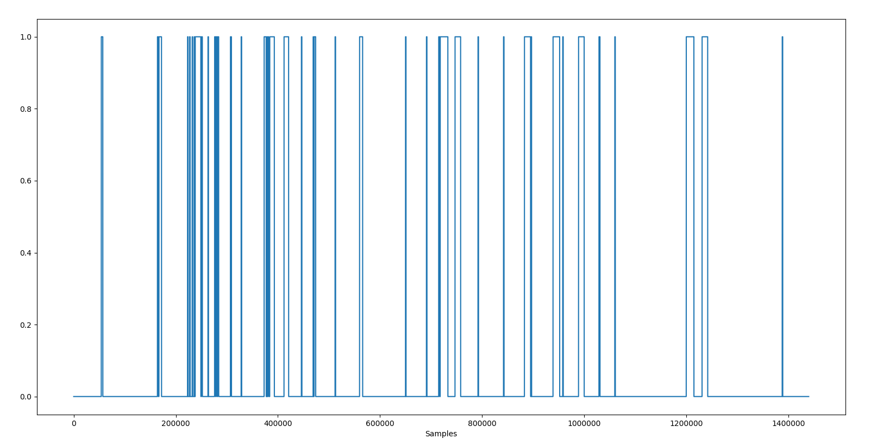

1. The Square Wave of Manatee Call Detection (Window Size=1000)

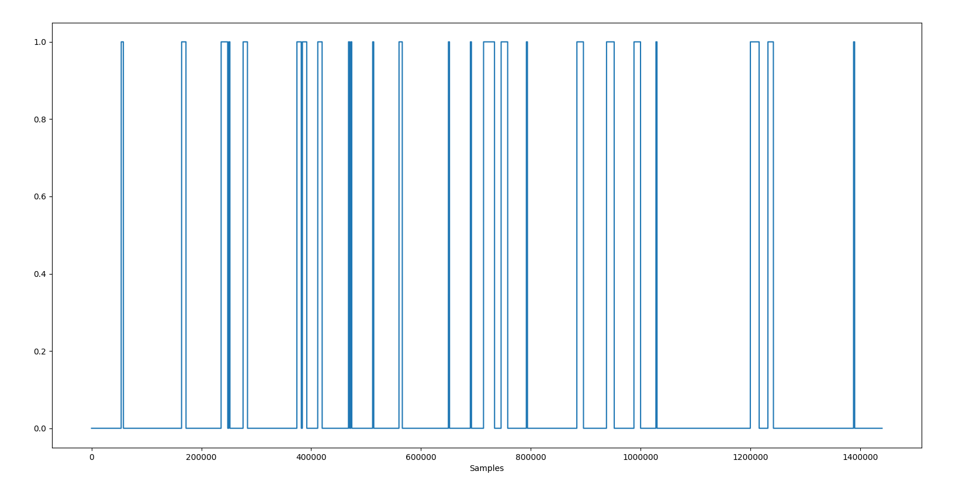

1. The Square Wave of Manatee Call Detection (Window Size=2000)

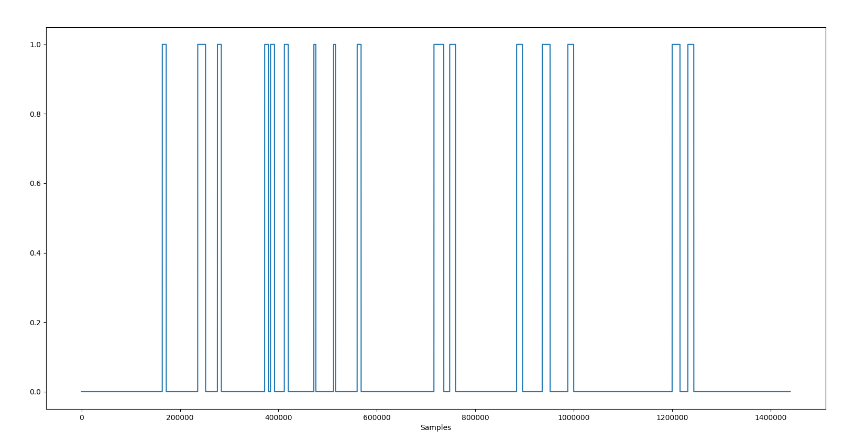

1. The Square Wave of Manatee Call Detection (Window Size=4000)

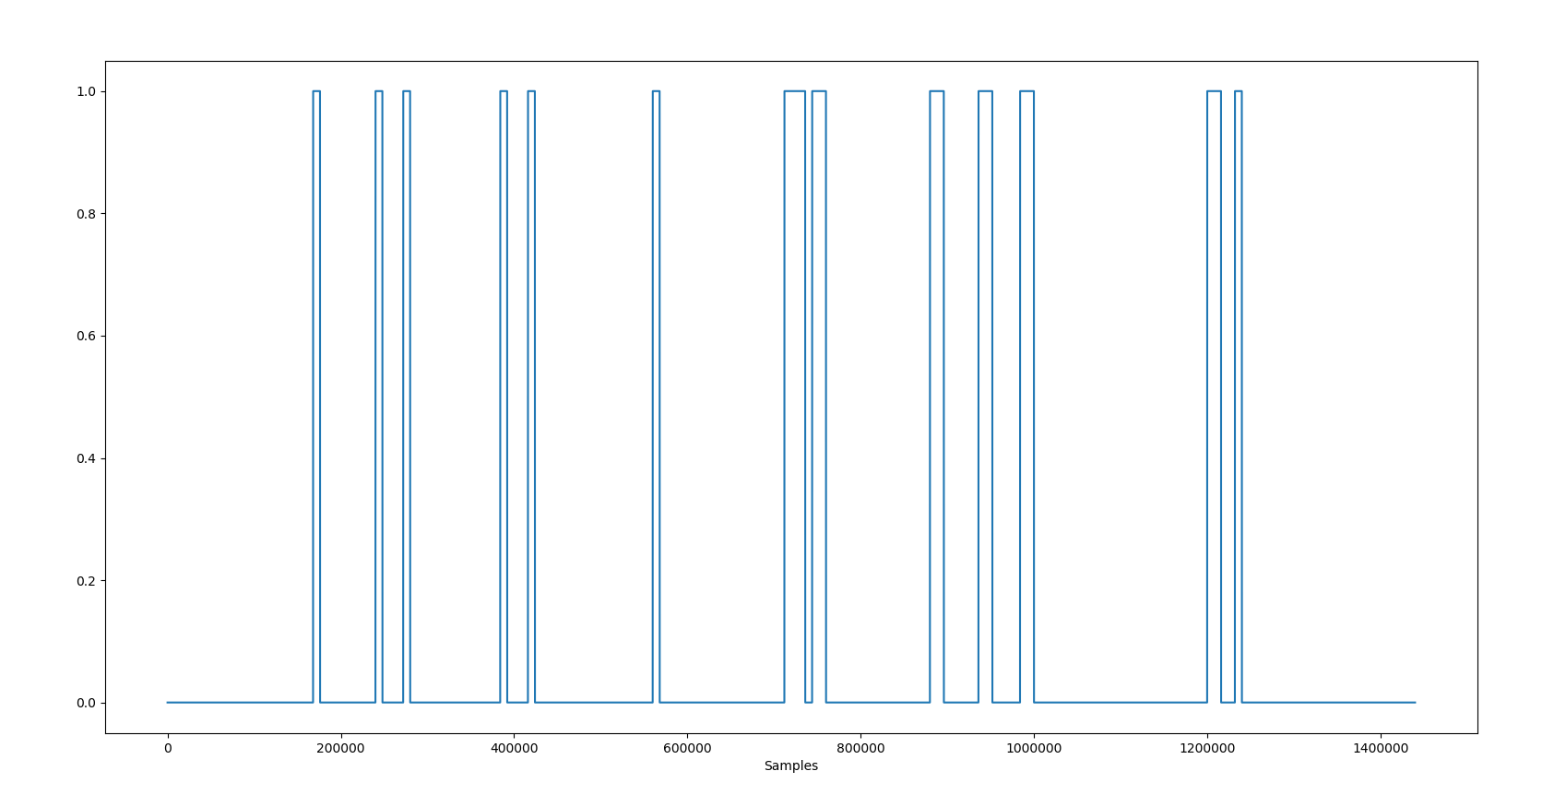

1. The Square Wave of Manatee Call Detection (Window Size=8000)

I test the model with the test data set with smoother window size = 1000, 2000, 4000, 8000. Fig. 5 to 8 show the square waves for the full duration of the test set, with high meaning manatee calls and low meaning background noise. We can see that the larger the window size, the less square waves, which means the less samples the trained models judge as a manatee call.

I hear the test data and mark locations of the manatee calls. There are 16 manatee calls in the test data. Fig. 9 shows the locations of those 16 manatee calls.

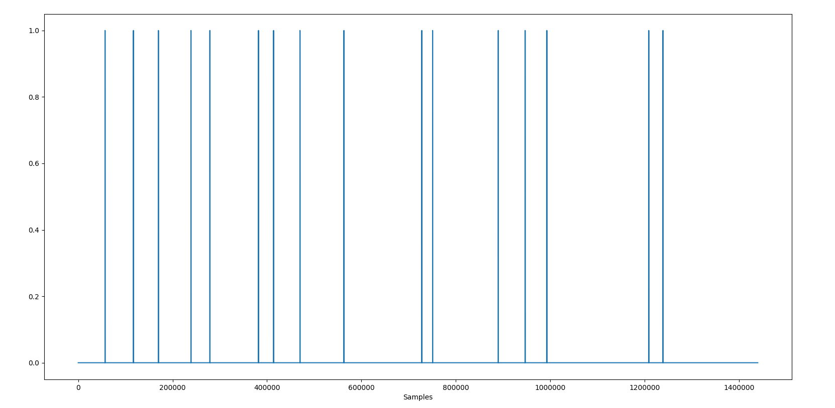

1. The Locations of Manatee Calls in Test Data

I change the window size and plot the square waves with high meaning manatee calls and low meaning background noise. Then, I compare the square waves with the real call position and calculate the true positive (TP) and false positive (FP) of each window size. Fig. 10 shows the receiver operating characteristic (ROC) curve of the NLMS solution.

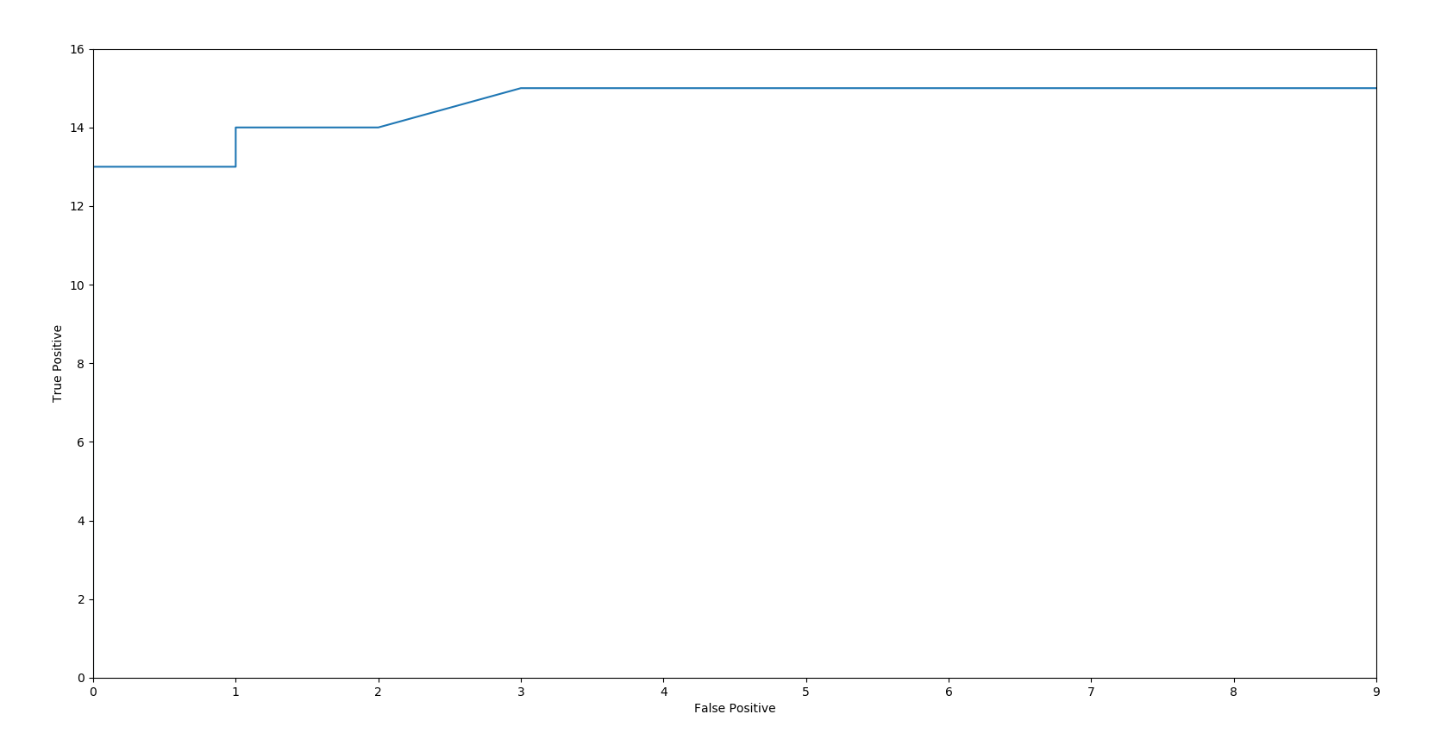

1. ROC Curve of NLMS Solution

# Detecting Manatee Calls Using SPRT and CUSUM Tests

## Introduciton of SPRT and CUSUM

The sequential probability ratio test (SPRT) is a specific sequential hypothesis test, developed by Abraham Wald (1947). It was extended to the multi-hypothesis case by Armitage (1950). Its research object is the so-called “sequential sampling plan”, and how to use the samples from this sampling plan for statistical inference. Sequential sampling plan refers to sampling a small number of samples without specifying the total number of samples in advance (number of observation or experiment), and then deciding to stop sampling or continue sampling, until the decision to stop sampling is made. On the contrary, the sampling plan which determines the number of samples in advance is called fixed sampling plan.

The cumulative sum (CUSUM) is a sequential analysis method first proposed by E. S. page of the University of Cambridge in 1954. It was extended to the multi-hypothesis case by Zhang (1989) and later Kerestecioglu (1993). CUSUM is used to detect abnormal data points in a relatively stable data sequence. The abnormal data point is the point when the average value or mean square deviation of the whole sequence begins to change and affects the stability of the whole set of data. So the most typical application of CUSUM is to detect the change of parameters in change detection. Since the order and size of data changes can be fully utilized by the CUSUM control method, it is quite suitable for detecting small shifts in the time serious.

## Principle of Detecting Manatee Calls by SPRT and CUSUM

The test consists of two steps: first, the active process at the beginning of the time series is identified using the multi-hypothesis SPRT. Then, the time series is monitored for change to a different process using the multi-hypothesis CUSUM algorithm. Once a change is detected, the CUSUM algorithm is reset and monitoring continues anew.

The SPRT is to understand many of the principles before the CUSUM. Since the mean square error performance surface has only a minimum value, as long as the convergence step is properly selected, regardless of the initial weight vector, it can converge to the smallest point of the error surface or within a neighborhood of it.

## Independent and Identically Distributed Test

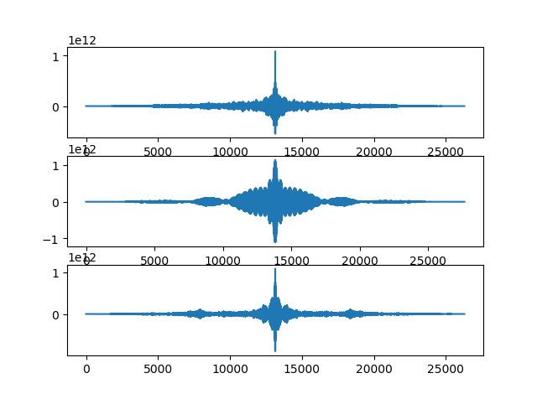

1. the Autocorrelation of Some Input Manatee Call Signals

First of all, we should check if the time serious is independent and identically distributed (IID). Fig. 11 shows the autocorrelation of some input manatee call signals. From Fig. 11 we can see that the autocorrelation of the manatee call signal is a delta function. So the manatee call signal is independent and identically distributed.

## Implementation Details and Test Results

From SPRT we can know that the noise signal is Gaussian distribution. For the statistical test, the size of segment should be smaller than the size of the every manatee call signal. The maximum length of those manatee call signals about 20000, so I set the size of segment = 2000 for the statistical test. Then I change the threshold from 2000 to 15000 to study the effect of the threshold.

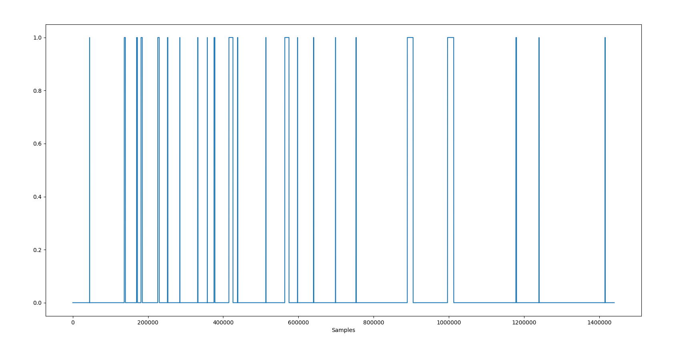

1. The Square Wave of Manatee Call Detection (Threshold=2000)

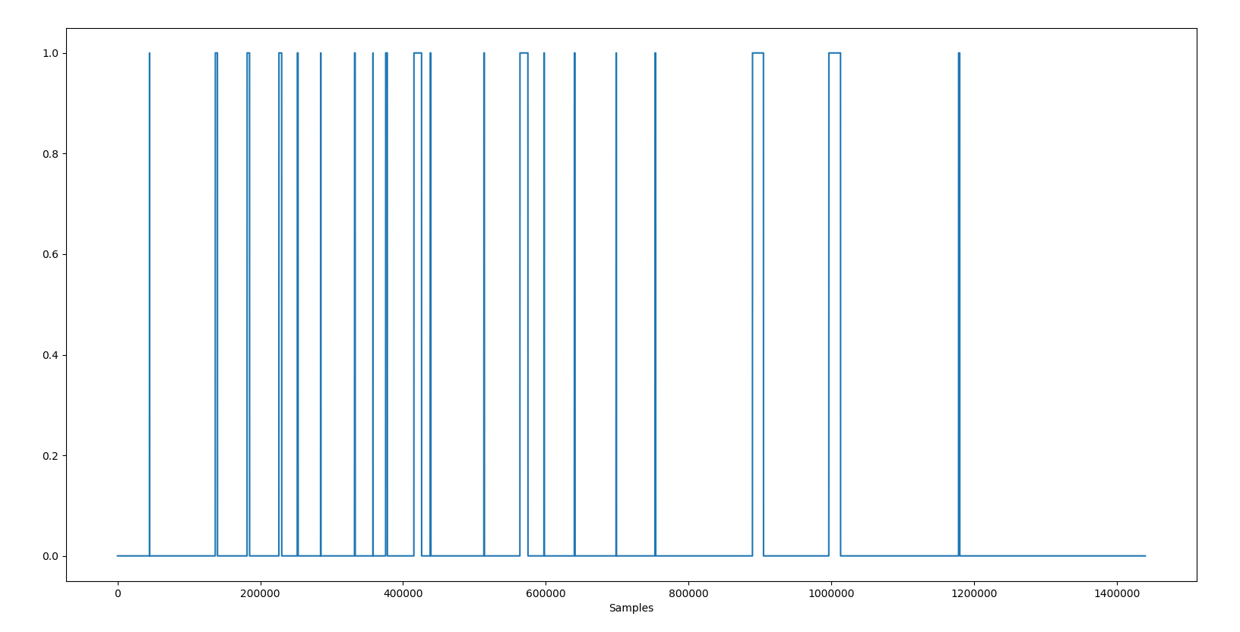

1. The Square Wave of Manatee Call Detection (Threshold =5000)

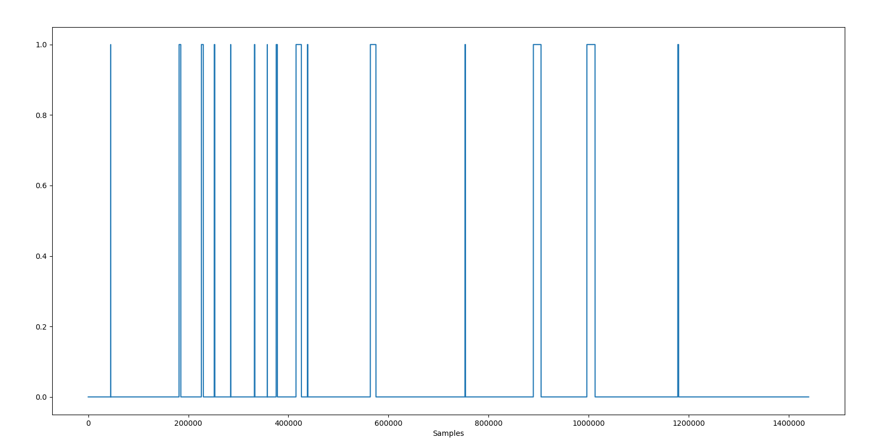

1. The Square Wave of Manatee Call Detection (Threshold =8000)

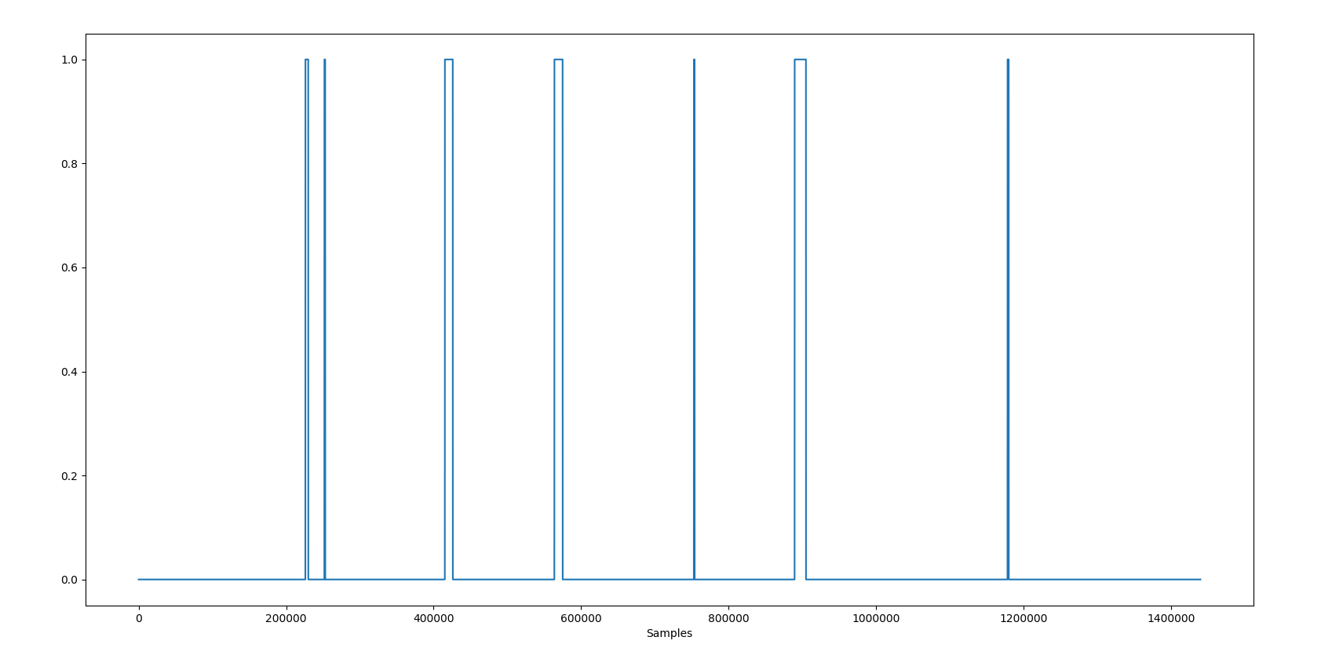

1. The Square Wave of Manatee Call Detection (Threshold =15000)

I use CUSUM algorithm to test the model with the test data set with threshold = 2000, 5000, 8000, 15000. Fig. 12 to 15 show the square waves for the full duration of the test set, with high meaning manatee calls and low meaning background noise. We can see that the larger the threshold, the less square waves, which means the less samples the trained model judges as a manatee call.

# Comparison of The Two Solutions

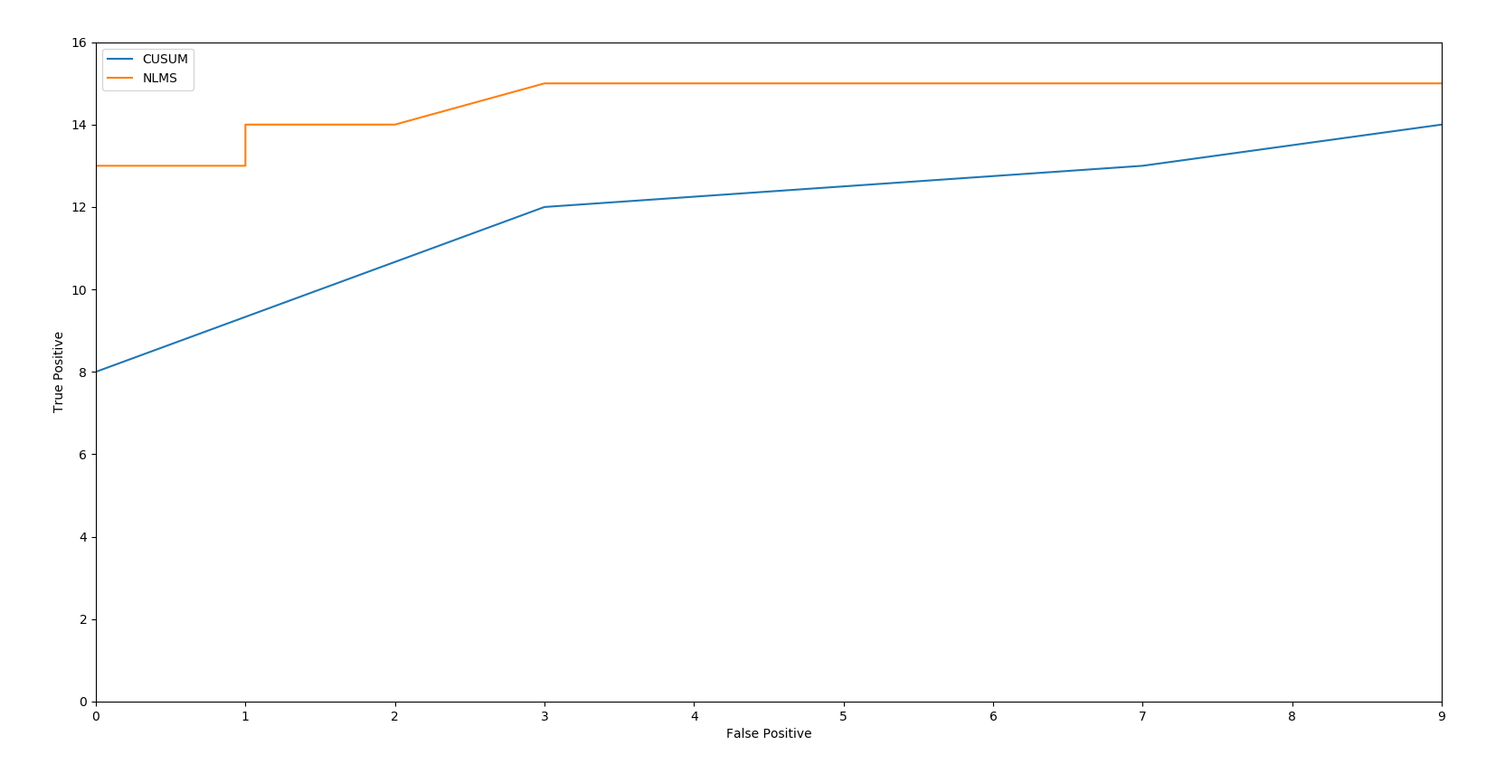

1. ROC Curve of NLMS Solution and CUSUM Solution

I change the threshold and plot the ROC curve of CUSUM algorithm. Fig. 16 shows the ROC curve of NLMS and CUSUM. The area under the curve (AUC) of ROC is equal to the probability that the solution will rank a randomly chosen positive instance higher than a randomly chosen negative one. So we can calculate the AUC of each model to judge the quality of the decisions. From Fig. 16 we can see that the AUC of NLMS is larger than the AUC of CUSUM, which means NLMS algorithm has better performance in detecting manatee calls.

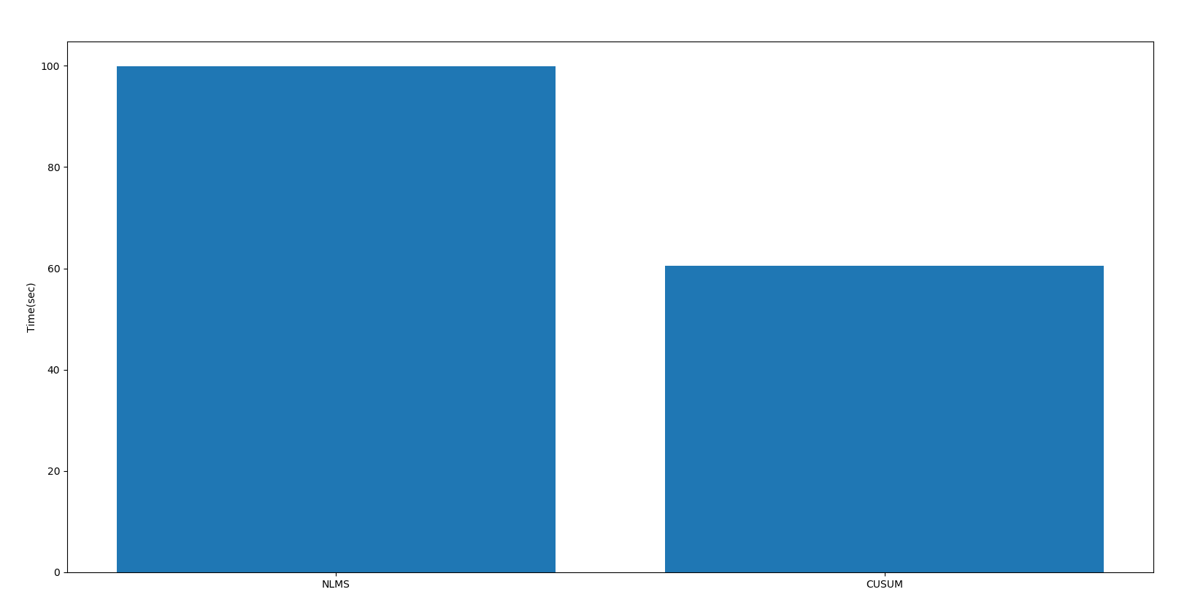

1. Running Time of NLMS Solution and CUSUM Solution

Fig. 17 shows the running time of NLMS solution and CUSUM solution. We can see that CUSUM has less running time than NLMS solution.

# Conclusion

In this project I design two machine learning detection approaches using NLMS algorithm and CUSUM algorithm to distinguish the manatee calls from the background noise. I select appropriate free parameters to train the models with ten manatee calls and background noise and test those models with test signal which includes unsegmented manatee calls mixed with background noise. I draw the ROC curve of both methods and compare the accuracy and running time of the two methods. The result shows that NLMS solution has higher accuracy and longer running time while CUSUM solution has lower accuracy and shorter running time.